Shape
Objective: Create two works of art that use shape.
One work of art must use only pencil.
This work must address one of the following from your reading
Representational or Abstract. Your work of art must also have volume.
The other work of art can use any medium you choose but
must address one of the following from your reading
Rectilinear,Curvilinear,Geometric,or Organic.
Both of these works of art are Due at the end of the week

Abstract done with pencil with volume example ( also organic )
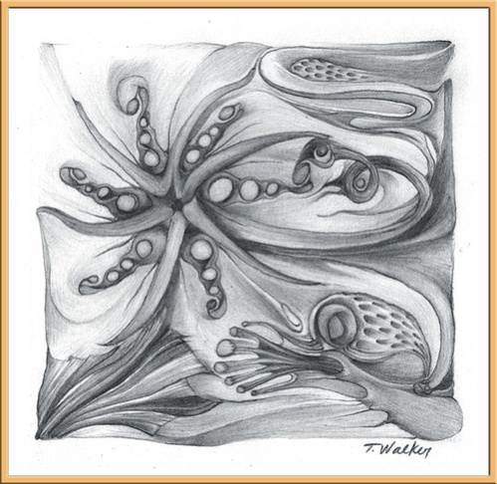
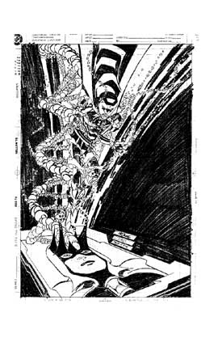Curvilinear Drawing

