Handscape
Objectives Students will:
- draw hands from life - careful observation
- combine realistic hand drawing in fantasy "scape"
- utilize elements of design - show good composition skills/principles of design - value shading
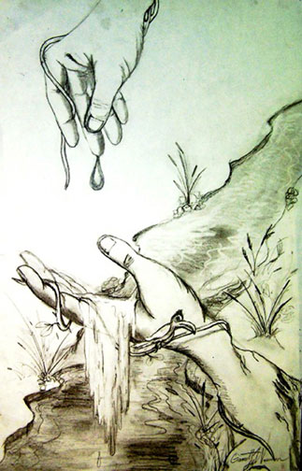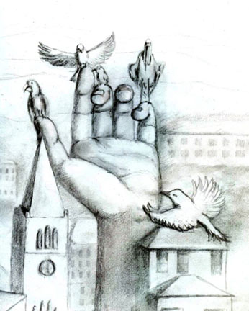

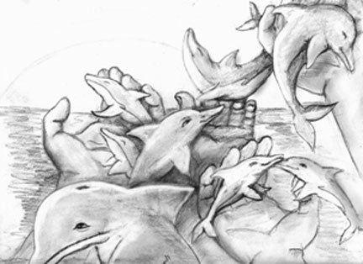

Materials
White Drawing Paper
Saral Transfer Paper (optional)
Pencils, Colored Pencils (optional)
look into Dali, Rene Magritte, Brad Holland, (blatant fantasy imagery) and then the Pre-Raphaelites etc. like John William Waterhouse, Rossetti, Mucha (atmospheric subtle fantasy).
Posters
The Persistence of Memory, by Salvador Dali
The Temptation of St. Anthony by Salvador Dali
Swans Reflecting Elephants by Salvador Dali
Intermission by Rene Magritte
Midnight Marriage by Rene Magritte
Procedures:
The project begins with students drawing their own hands. After, drawings were reviewed in class critique.
Instruction during this phase concentrated on facilitating students ability to see how principles and elements learned thus far, applied to creating any illusion: (record shapes first, then break shapes down (receding or projecting out of page) using overlapping, emphasis of line, size disparity, etc.)
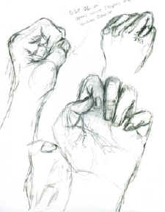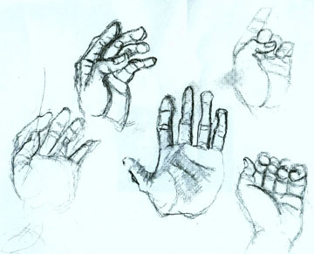

Must portray the hand as a prominent, totally unusual & unexpected ‘character’ in its environment. Show hands interacting w/that environment… passively, or actively.
They execute the finish… This phase from sketch to final includes lessons in how to transfer a drawing with light box, or graphite sheet, how to selectively keep or discard elements of a sketch, how to size up or down for a final…etc …

